Digital Multi-channel
Biocare ECG-8080 Tablet ECG Machine

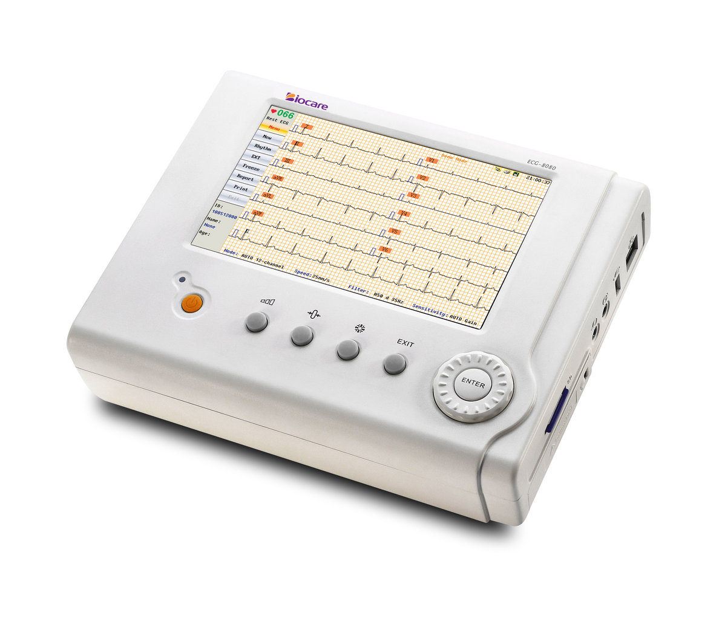

Features
7 inches color LCD with grid line, display as printing
Touch-screen, input by hand writing for convenient operation
Unlimited SD card data storage with useful management tools
Unique acquisition technique, facilitate abnormal ECG acquisition
12+1 leads display and print out make observation easier
Real time waveform freezing, record any period of waveform by different format
Long life Li-ion battery for continuous operation
Wire or wireless data transmission, information management and sharing system
Multi-language versions available
Supports a USB laser printer
Includes a 2 year warranty

Biocare ECG-8080 Tablet Digital ECG Machine

Digital Multi-channel ECG
